Set up prerequisites for Docker Install
- This was completed on an Ubuntu Server. Prior to Setting up Docker on your machine, you will need to do these things. Please input the following commands.
sudo apt update
sudo apt install ca-certificates curl
sudo install -m 0755 -d /etc/apt/keyrings
sudo curl -fsSL https://download.docker.com/linux/ubuntu/gpg -o /etc/apt/keyrings/docker.asc
sudo chmod a+r /etc/apt/keyrings/docker.asc
echo "deb [arch=$(dpkg --print-architecture) signed-by=/etc/apt/keyrings/docker.asc] https://download.docker.com/linux/ubuntu $(. /etc/os-release && echo "$VERSION_CODENAME") stable" | sudo tee /etc/apt/sources.list.d/docker.list > /dev/null

Install Docker and Ubuntu

- Input the following commands to install Docker
sudo apt update
sudo apt install docker-ce docker-ce-cli containerd.io docker-buildx-plugin docker-compose-plugin

- Test Docker to see that it works using this command

sudo docker run hello-world

- Join your use to the docker group (so you don’t need to keep typing Sudo)

sudo usermod -aG docker $USER

- Clone Wazuh Directory

git clone https://github.com/wazuh/wazuh-docker.git -b v4.14.5

cd wazuh-docker/single-node/

- Set up certificate
docker compose -f generate-indexer-certs.yml run --rm generator



- docker compose up -d

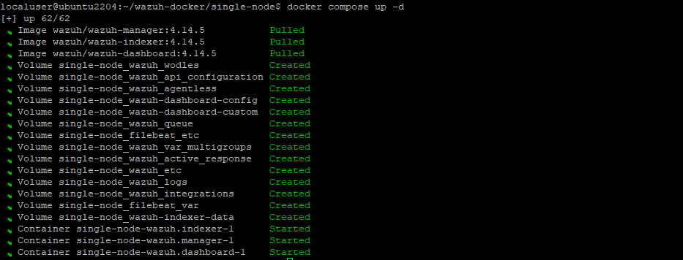

- Test IP


Documentation: https://documentation.wazuh.com/current/deployment-options/docker/wazuh-container.html
Default Credentials are:
Username: admin
Password: SecretPassword

Wazuh Agent Setup

- Go to deploy new agent

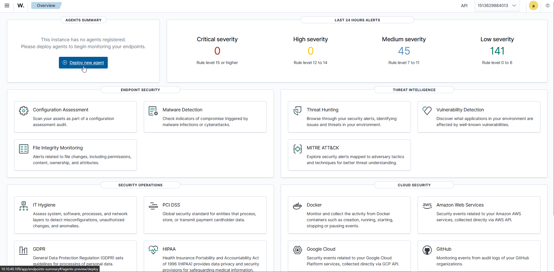

- Set up your choice.
Server address is your current Wazuh ip address (my case: 10.10.40.109)
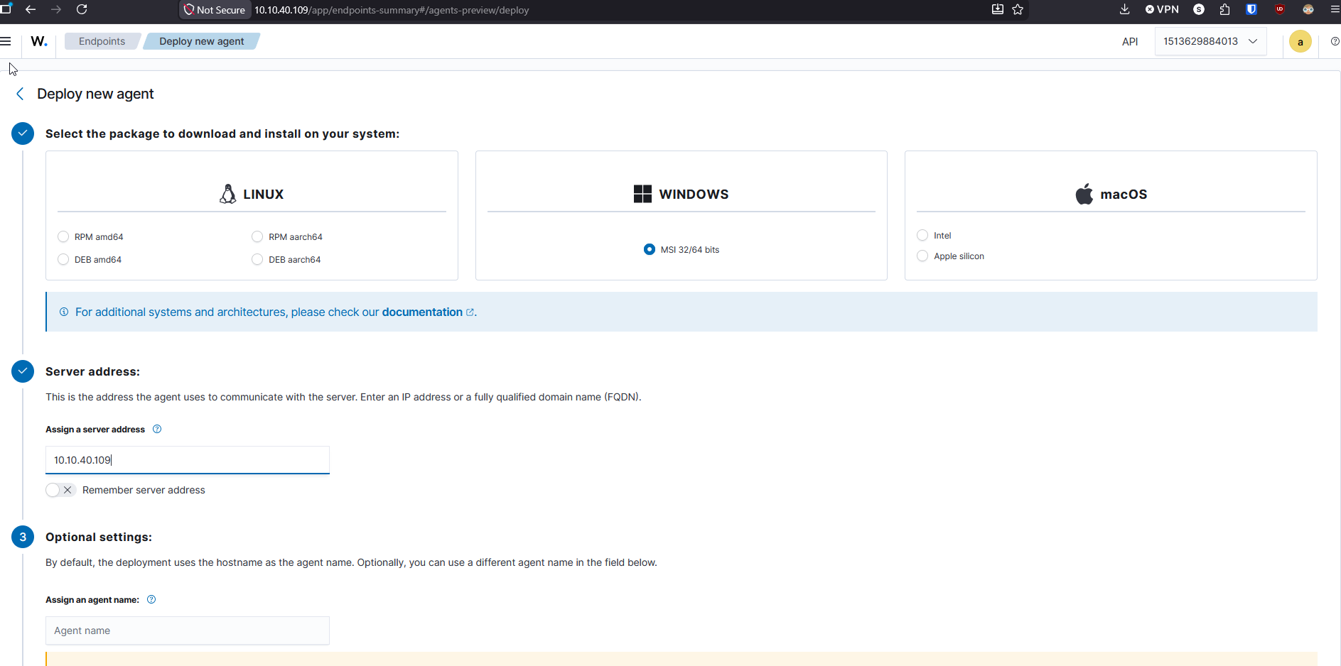

- Copy and paste the command in powershell on admin
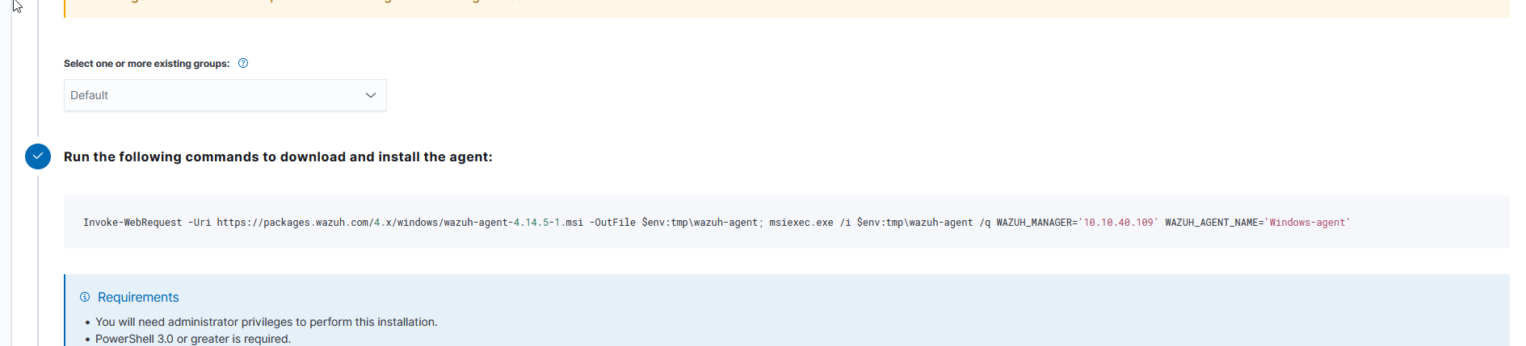

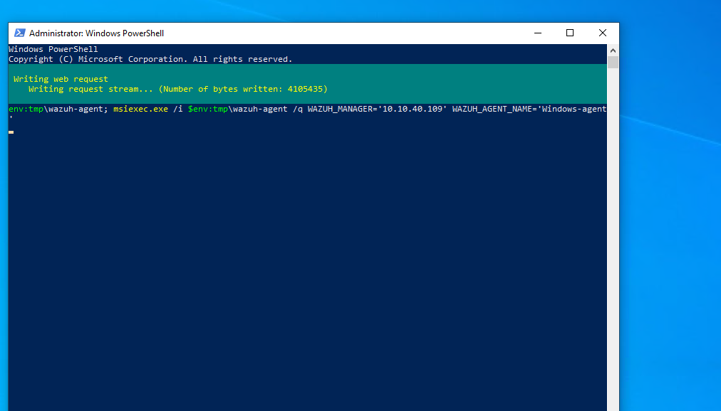

- Net start wazuh or start-service wazuhsvc

Installing Ubuntu Agent
- Go to Deploy New Agent
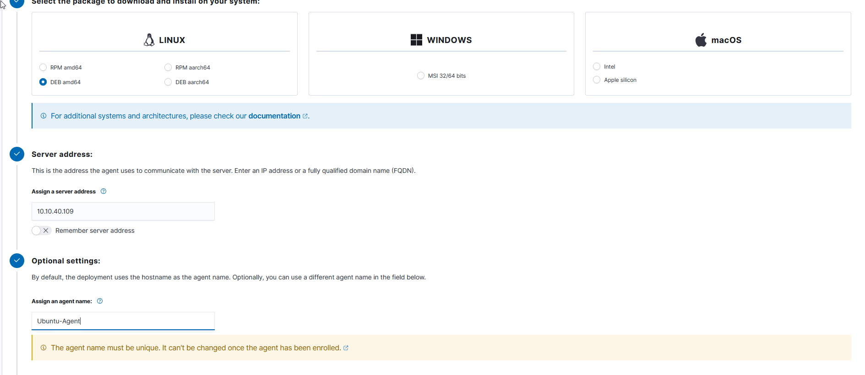

- Copy and paste the commands in ubuntu
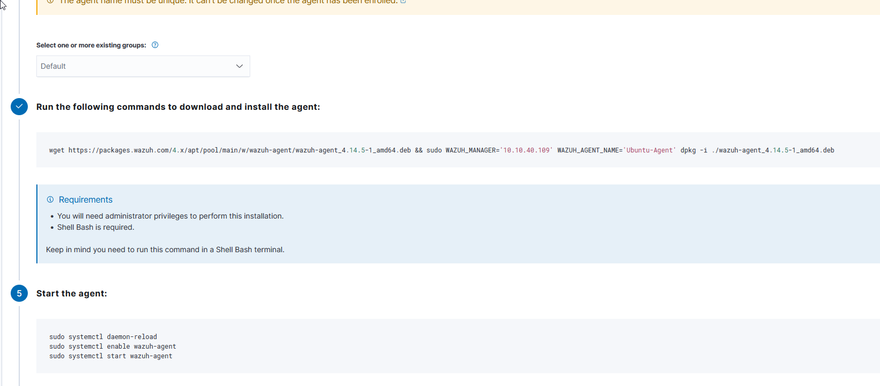
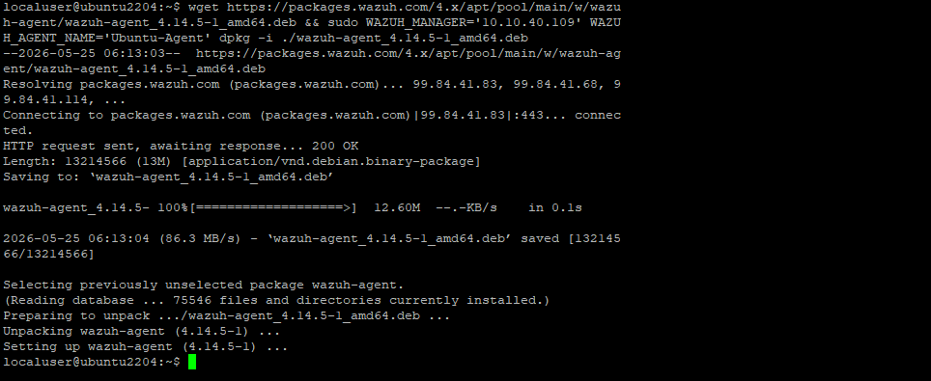

- Start the wazuh service
sudo systemctl daemon-reload
sudo systemctl enable wazuh-agent
sudo systemctl start wazuh-agent
- Check Status
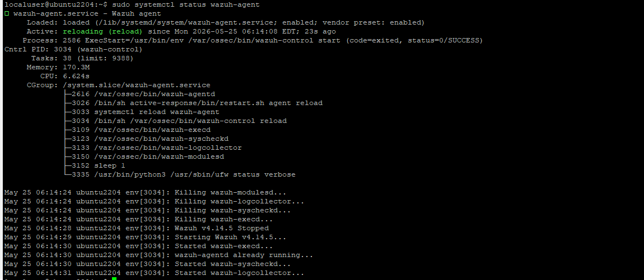

Testing to Make Sure Wazuh is Working
- Run as cmd

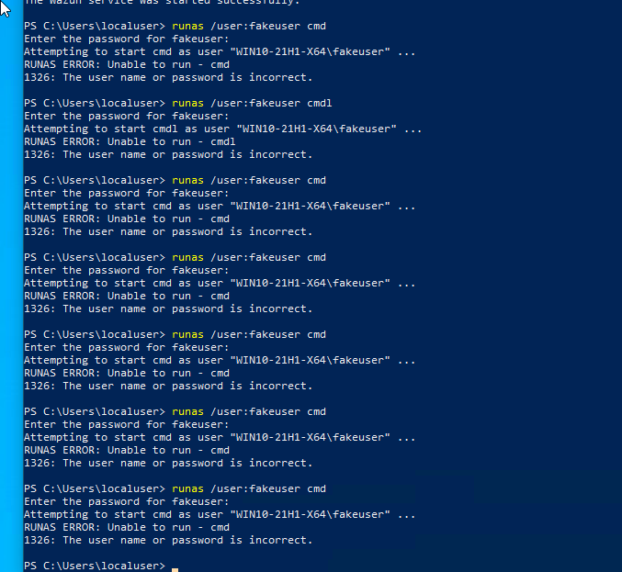

- Go to wazuh - > Expolore -> Discover
- Check for failed logins
dql query : data.win.system.eventID:4625

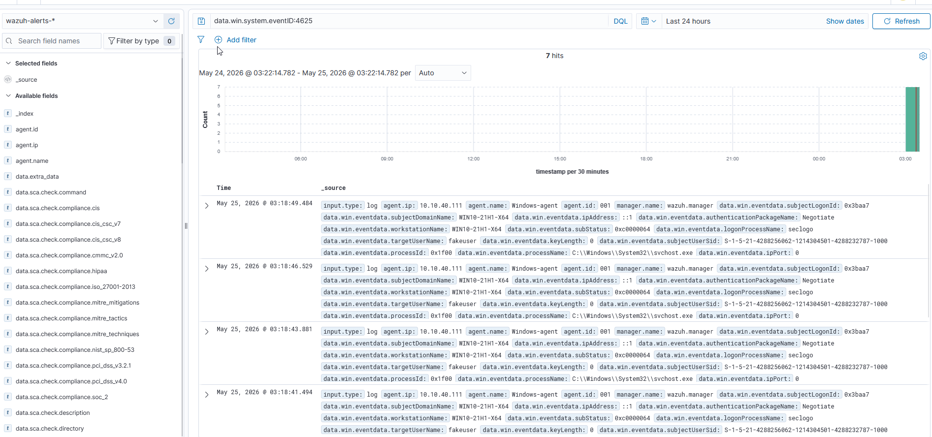

- Test with ubuntu as well

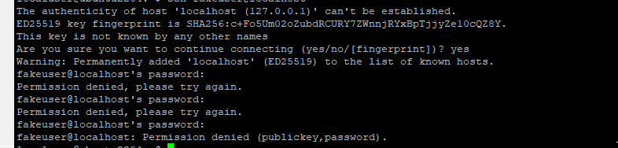

Ssh fakeuser@locallhost

Dql query: Authentication_failed

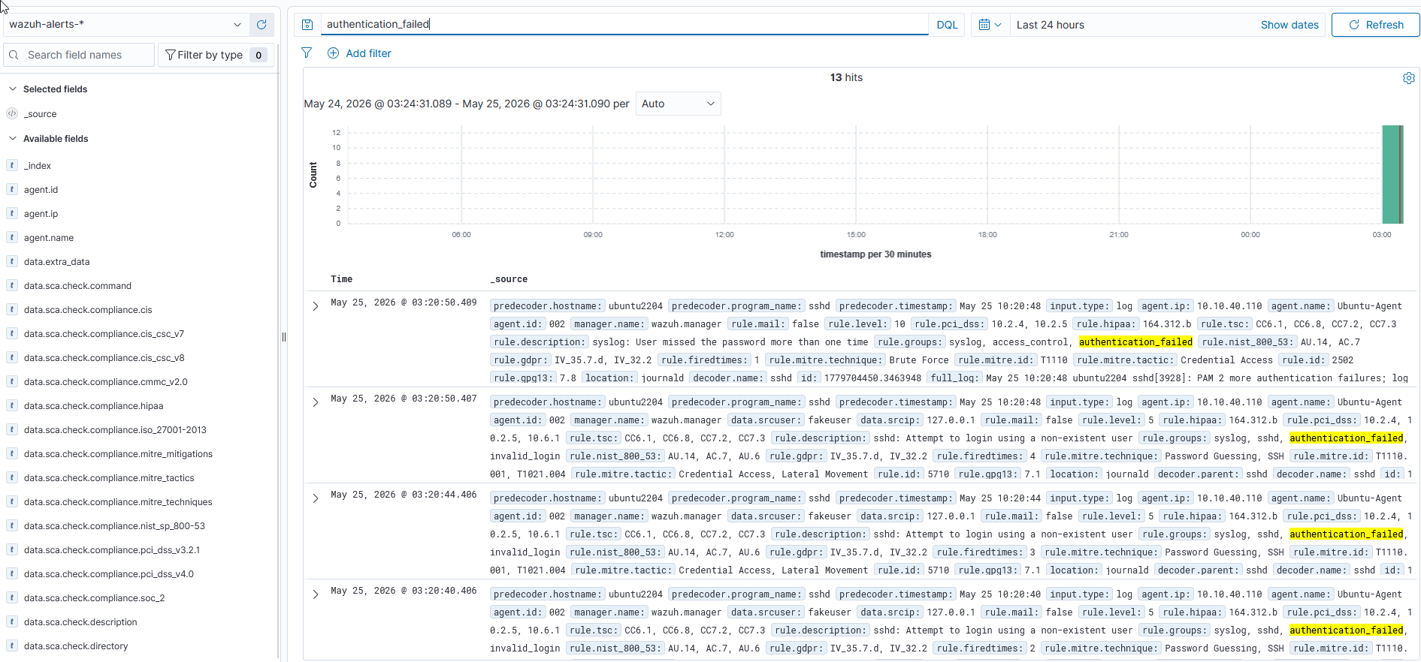

Tuning For First Rule
- Go to Server management -> rules
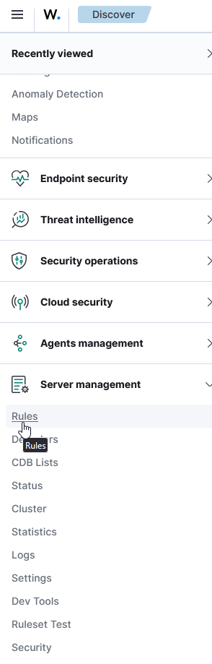

- Go to add new rules rile
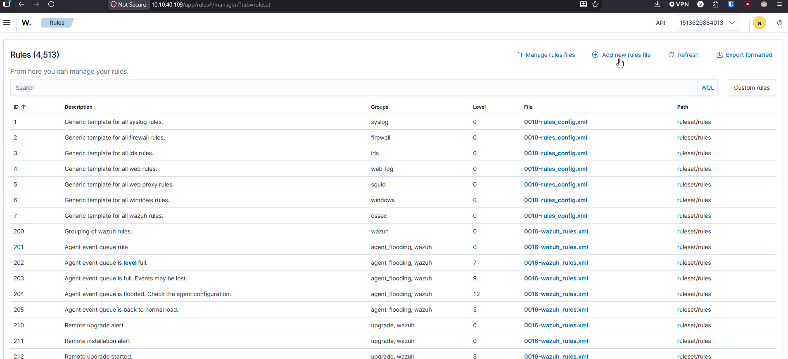

- Name the file and add these two. This will provide a tuning of the rule for failed loging attempts for linux and Windows up to 5 attempts.

<group name="local,syslog,sshd,windows,authentication,">
<group name="local,sshd,authentication,">

<rule id="100100" level="8" frequency="5" timeframe="60">
<if_matched_group>authentication_failed</if_matched_group>
<same_source_ip />
<description>Multiple SSH authentication failures from same source IP</description>
</rule>

<rule id=”100101” level=”8” frequency=”5” timeframe=”60”>
<if_matched_group>windows</if_matched_group>
<match>4625</match>
<description>Multiple Windows failed logins detected</description>
</rule>

</group>
- Make sure to name it and save it
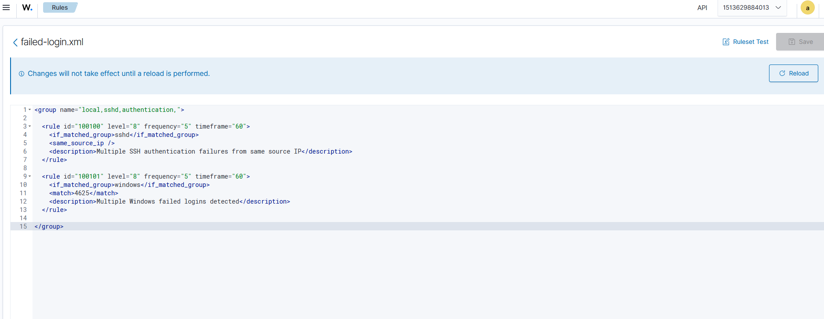

- Click Reload button for changes to take effect

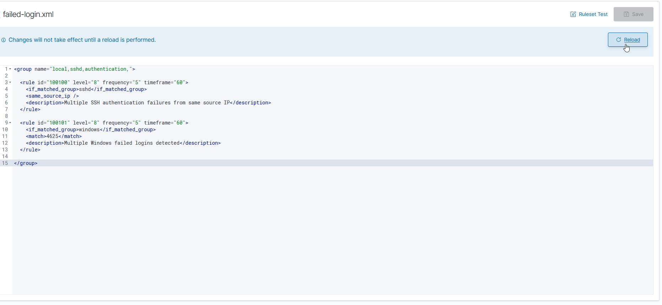

How to Test it

- First do 3 failed login attempts and search for rule.id:100101 in DQL. Nothing should show up
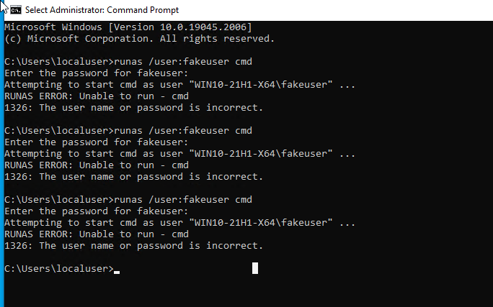
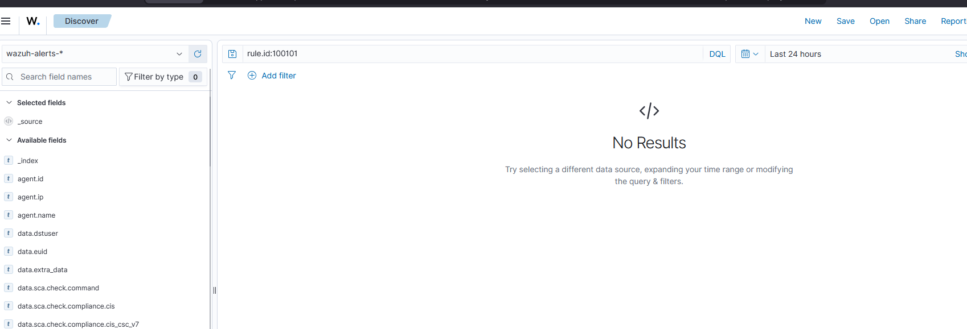

- Next try doing it five times and search up the same rule and you should see it.
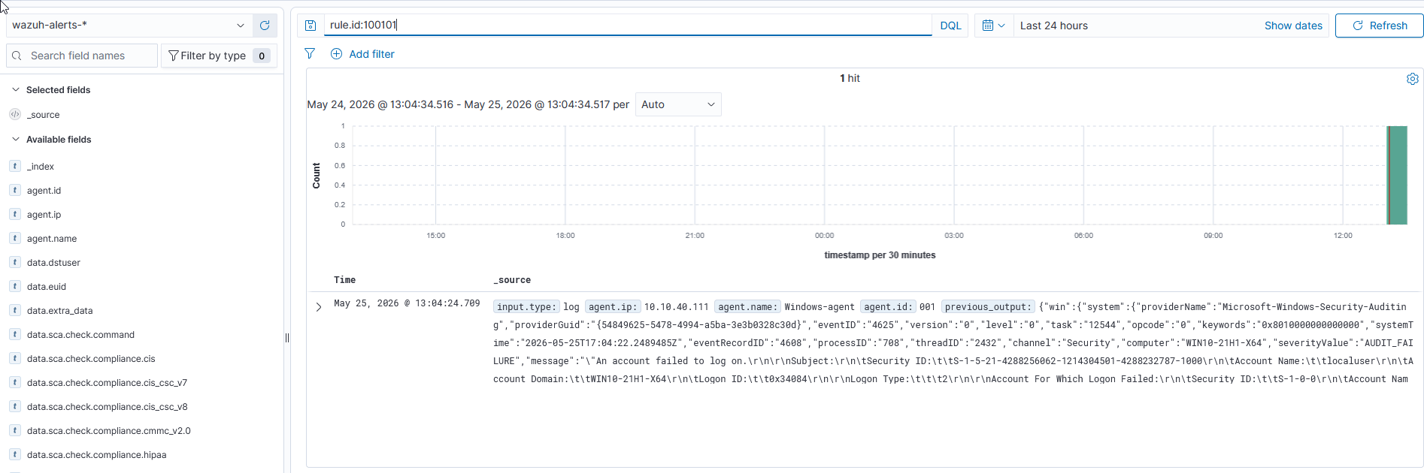

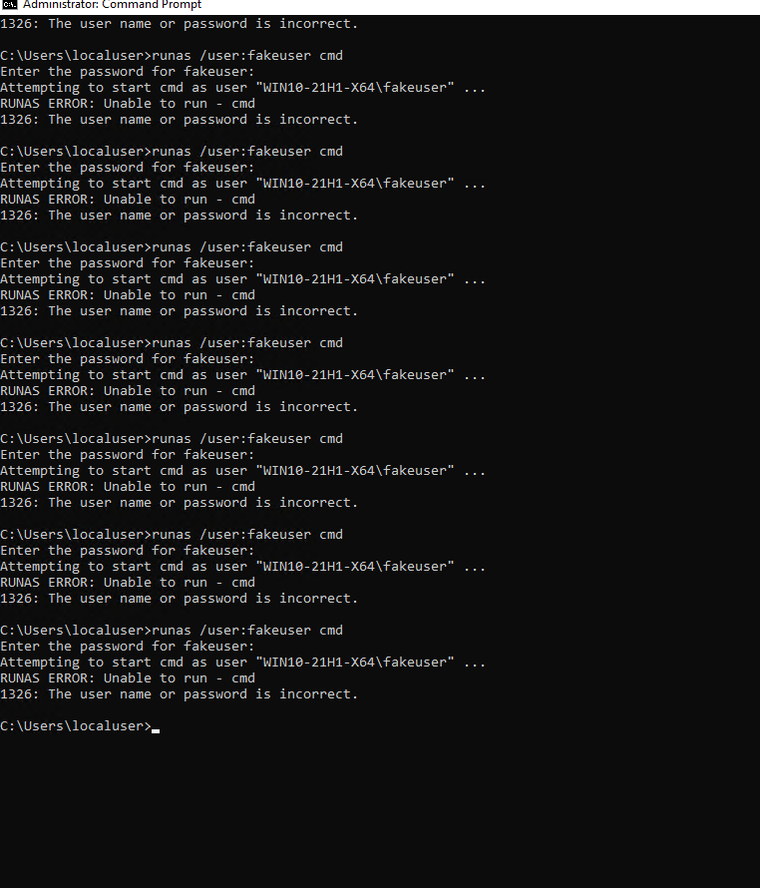

- Do the same thing with Linux
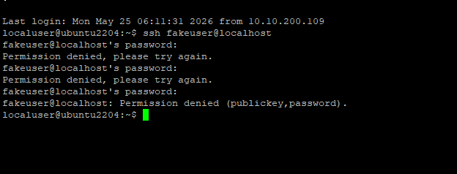

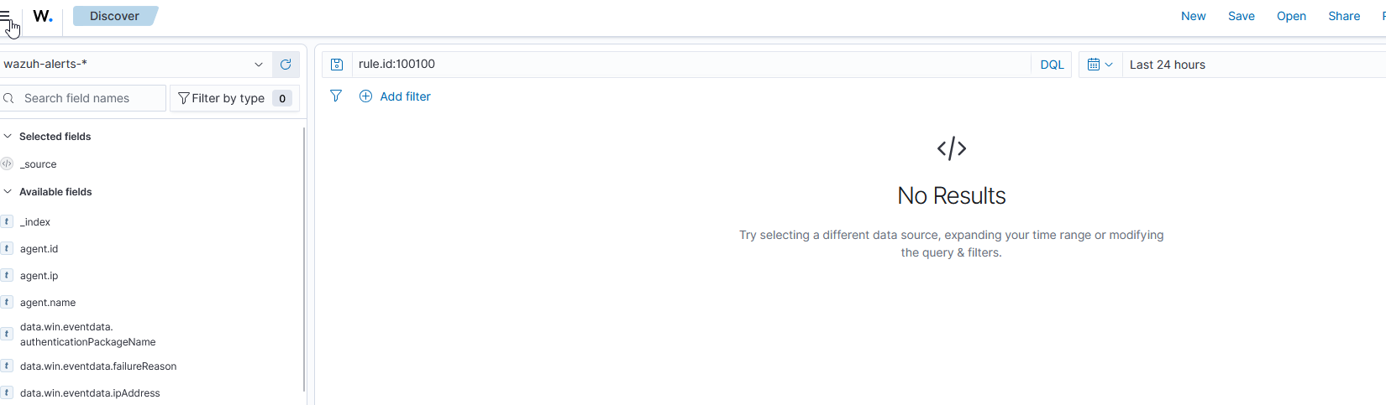

- Then try with multiple signins.
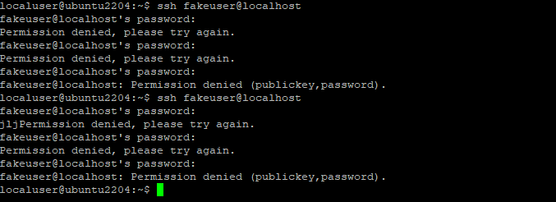

(SOMETHING FAILED HERE WITH LINUX)

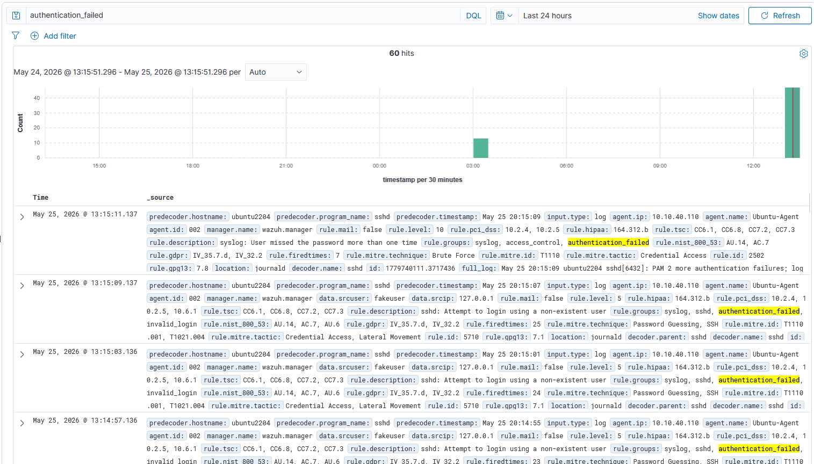

Process Creation Tuning
- Before testing this rule, make sure auditpolicy is on
Type
auditpol /get /subcategory:"Process Creation"
auditpol /set /subcategory:"Process Creation" /success:enable /failure:enable
auditpol /get /subcategory:"Process Creation" (AUDITPOL WONT PERSIST ON REBOOT) (USE LOCAL SECURITY POLICY OR REGISTRY)

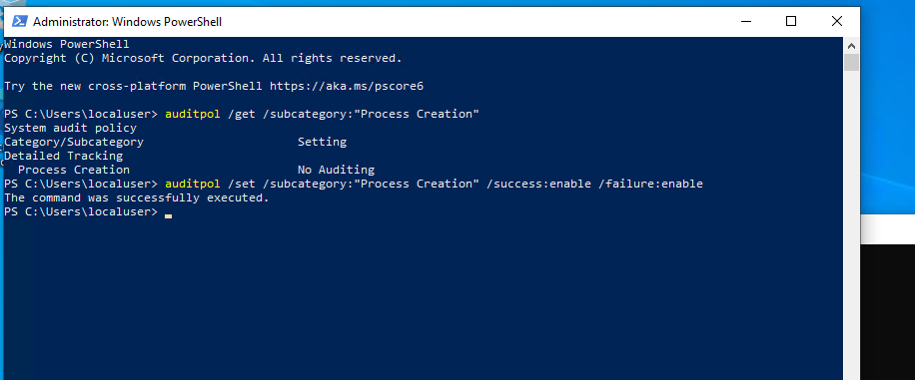
- This is for process creation with CMD and Powershell

<group name="local,windows,process_creation,">

<rule id="100102" level="8" frequency="5" timeframe="60">
<if_matched_group>windows</if_matched_group>
<match>powershell.exe</match>
<description>Multiple PowerShell executions detected</description>
</rule>

<rule id="100103" level="8" frequency="5" timeframe="60">
<if_matched_group>windows</if_matched_group>
<match>cmd.exe</match>
<description>Multiple CMD executions detected</description>
</rule>

</group>
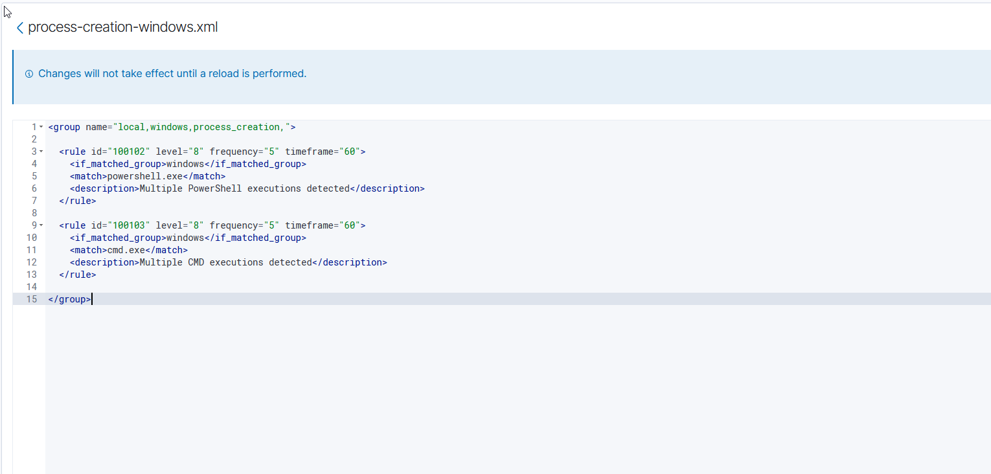
Make sure to reload after you finish.

- For testing purposes, make sure you open cmd or powershell 5 times or more and check rule.id:100102 or rule.id:100103 for DQL query.
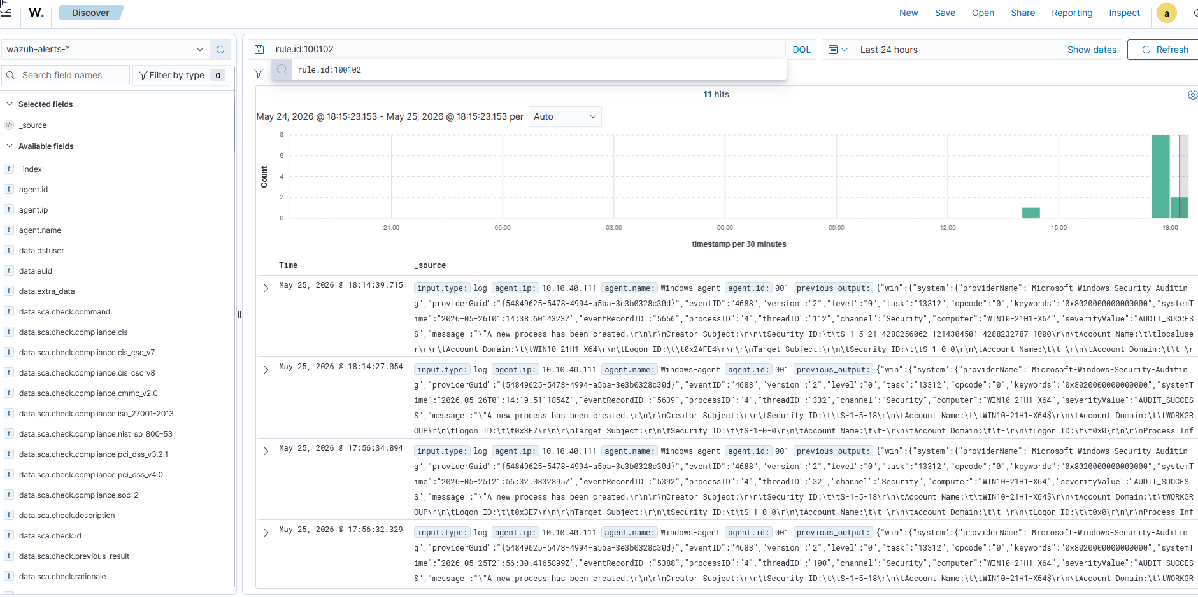

Service-State Changes – Third Tuning Rule
- For the last rule, we will focus on Service state changes. This is when a service is turned off or on or restarted. Here is the xml rule for service-state changes for Linux and Windows.
- <group name="windows_services,linux_services,service_state,">
<!-- Windows Service State Changes -->
<rule id="100200" level="3">
<if_sid>60000</if_sid>
<field name="win.system.eventID">^7036$</field>
<description>Windows Service State Changed</description>
<options>no_full_log</options>
</rule>
<!-- Critical Windows Service Stopped -->
<rule id="100201" level="12">
<if_sid>100200</if_sid>
<field name="win.eventdata.param1">Windows Defender Antivirus Service</field>
<field name="win.eventdata.param2">stopped</field>
<description>CRITICAL: Windows Defender Service has stopped</description>
</rule>
<!-- Linux systemd Service State Changes -->
<rule id="100202" level="3">
<if_matched_group>syslog</if_matched_group>
<match>systemd</match>
<description>Linux systemd service state change detected</description>
<options>no_full_log</options>
</rule>
<!-- Critical Linux SSH Service Restart -->
<rule id="100203" level="10">
<if_sid>100202</if_sid>
<match>ssh.service</match>
<description>Critical Linux SSH service activity detected</description>
</rule>
</group>
- Make sure to reload changes
- To practice the rule, for windows, do restart-service spooler. And for linux, do sudo systemctl restart ssh.

- Rule didn’t work. Will need to test further options

